Smart Pest Repeller

Andrew Albritton

Michael McNeil

Melquisedec Ordonez

**Interface Control Document**

REVISION – 0

28 September 2023

Interface Control Document

for

Smart Pest Repeller

Prepared by:

_____________________________

Author Date

Approved by:

_____________________________

Project Leader Date

_____________________________

John Lusher II, P.E. Date

_____________________________

T/A Date

**Change Record**

| **Rev.** | **Date** | **Originator** | **Approvals** | **Description** |
| --- | --- | --- | --- | --- |
| **0** | 9/25/23 | ALL |  | Draft Release |

**Table of Contents**

**List of Tables 15**

**List of Figures 16**

**1. Overview** **17**

**2. References and Definitions** **18**

2.1 References 18

2.2 Definitions 18

3. Physical Interface **19**

3.1 Weight 19

3.2 Dimensions 19

**4. Thermal Interface** **20**

**5. Electrical Interface** **21**

5.1 Primary Input Power 21

5.2 Signal Interfaces 22

5.3 Video Interfaces 22

**6. Communications / Device Interface Protocols** **23**

6.1 Host Device 23

6.2 Device Peripheral Interface 23

**List of Tables**

**Table 1. System Weights 19**

**Table 2. System Dimensions 19**

**Table 3. Maximum Power Delivery Values 21**

**Table 4. Standard Operating Delivery Values 22**

**List of Figures**

# Figure 1. Electrical Interface Diagram 21

# Overview

This document will provide a detailed description of how our power, motion, camera, processing, and emitting systems will be connected. Also, this document will outline the connections between each of these subsystems as well as requirements at each of these connections. We will also elaborate on the logic connecting the processing subsystem with the transmission subsystem.

# References and Definitions

## 2.1 References

Refer to section 2.2 in the Functional System Requirements documentation.

## 2.2 Definitions

mm Milli-Meter

uA Micro-Amp (10^-6 A)

mA Milli-Amp (10^-3 A)

A Amp

mW Milli-Watt (10^-3 W)

W Watt

V Volt

mV Milli-Volt

kHz KiloHertz (1000 Hz)

TBD To Be Determined

# Physical Interface

## 3.1 Weight

| **Component** | **Weight** | **Number of Items** | **Total Weight** |
| --- | --- | --- | --- |
| Coral AI dev Board | 191.17g | 1 | 191.17g |
| Camera | TBD | 1 | TBD |
| Motion Sensor | 6.5 g | 1 | 6.5 g |
| Power PCB | TBD | 1 | TBD |
| Signal Generator | 18.14g | 1 | 18.14g |
| Ultrasonic Emitter | 4.8g | 1 | 4.8g |

*Table 1: System Weights*

## 3.2 Dimensions

| **Component** | **Length** | **Width** | **Height** |
| --- | --- | --- | --- |
| Coral AI dev Board | 85mm | 56mm | 22.38mm |
| Camera | 25mm | 25mm | 6.98mm |
| Motion Sensor | 45mm | 25mm | 19.5mm |
| Power PCB | TBD | TBD | TBD |
| Signal Generator | 68.56mm | 55.88mm | 27.94mm |
| Ultrasonic Emitter | 14.4mm | 14.4mm | 9mm |

*Table 2: System Dimensions*

# 4. Thermal Interface

The Coral AI Dev Board will have a mounted heat sink with a fan connected above the heat sink. The fan speed will vary depending on system load/temperature. The board’s temperature rating is 0-50℃, so it will be able to perform without extra heat control in the environment specified in section 3.2.1.4 of the FSR.

# 5. Electrical Interface

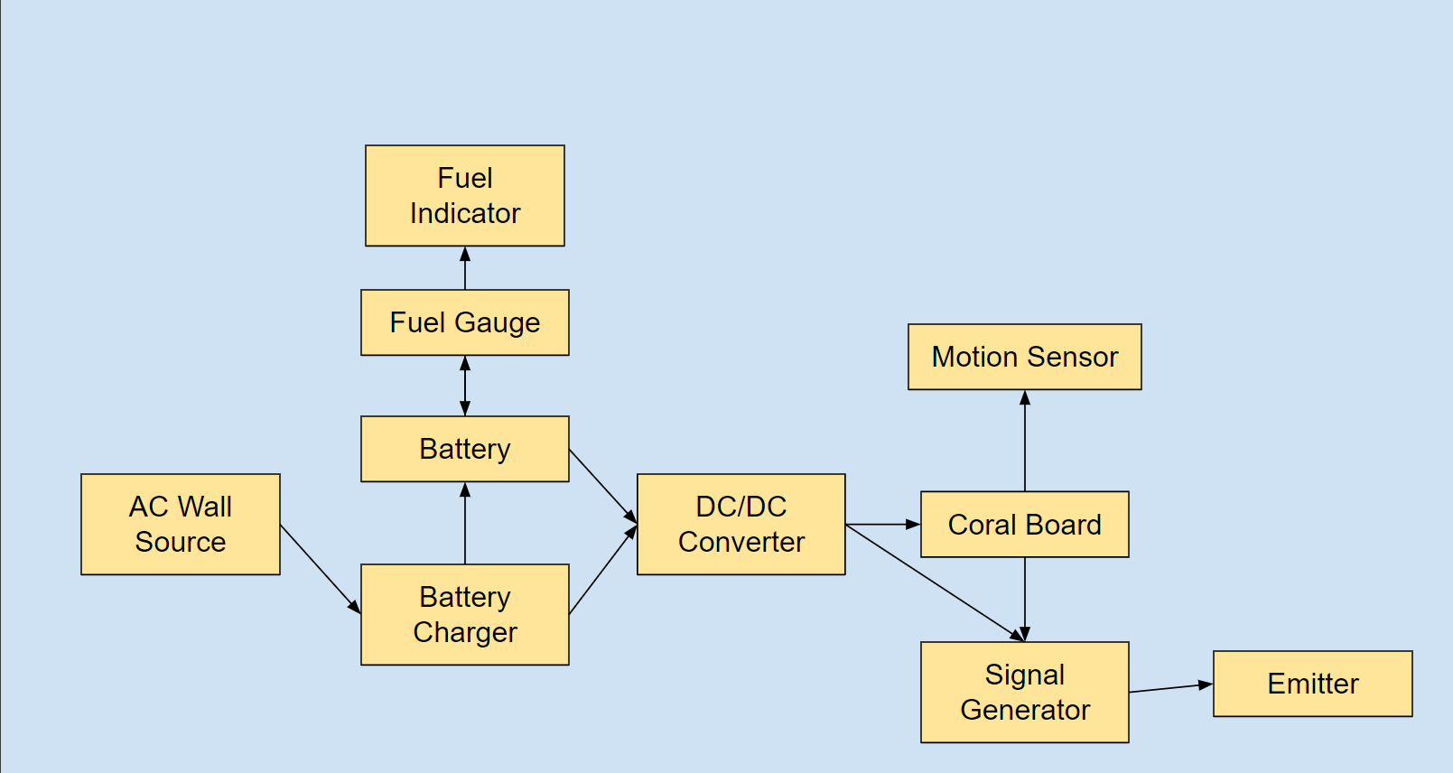

*Figure 1: Electrical Interface Diagram*

## 5.1 Primary Input Power

**5.1.1 Maximum Values**

| **Component** | **Voltage** | **Current** | **Power** |
| --- | --- | --- | --- |
| Coral AI dev Board / Camera | 5 V | 3 A | 15 W |
| Motion Sensor | 5.5 V | 100 uA | .55 mW |
| Battery Charger | TBD | TBD | TBD |
| Battery Fuel Gauge | TBD | TBD | TBD |
| DC/DC Converter | TBD | TBD | TBD |
| Signal Generator | 5V | 76mA | 380mW |
| Ultrasonic Emitter | TBD | TBD | TBD |

*Table 3: Maximum Power Delivery Values*

**5.1.2 Standard Operating Values**

| **Component** | **Voltage** | **Current** | **Power** |
| --- | --- | --- | --- |
| Coral AI dev Board / Camera | 5 V | 2 A | 10 W |
| Motion Sensor | 3.3 V | 90-100 uA | .297-.33 mW |
| Battery Charger | TBD | TBD | TBD |
| Battery Fuel Gauge | TBD | TBD | TBD |
| DC/DC Converter | TBD | TBD | TBD |
| Signal Generator | 3.3V | 37mA | 122mW |
| Ultrasonic Emitter | TBD | TBD | TBD |

*Table 4: Standard Operating Power Delivery Values*

## 5.2 Signal Interfaces

***5.2.1 Motion Signal Interface***

The motion sensor shall be connected to the GPIO pins found on the Coral Dev Board. These pins will be read as a control signal which will be sent to the camera system program. When the camera program receives the control signal, three photos will be taken and processed over the span of three seconds.

***5.2.2 Transmission Signal Interface - Mel***

The signal generator will receive a signal from the Coral Board. The Board will send a unique signal for each of the three pests it has detected. Once the signal generator receives the signal it will generate the appropriate signal for the transceiver to emit.

## 5.3 Video Interfaces

As mentioned in section 5.2.1, the camera will receive a control signal from the motion sensor, and take one photo per second to be processed within that given second. The camera will send an active array of size of 2582 x1944 which shall undergo compression before processing to a size of 640x640.

# 6. Communications / Device Interface Protocols

## 6.1 Host Device

The host device shall be the Coral AI dev board. The board has 11 GPIO pins which will be sufficient for our device’s needs. The Coral Camera has a separate connection point from the GPIO interface, allowing for more room for control implementation.

## 6.2 Device Peripheral Interface

The camera will be connected to the Coral AI board with a specially designed Coral compatible 24-pin flex connector. The connector contains 10 differential data ports for image data transmission. Pin 17 will be used for camera control, while a pulse signal through pin 23 will be used to reset the camera when booting.

The motion sensor has a single out pin which will be connected to the Coral Board’s GPIO interface to allow for device communication.

The transmitter will communicate with the host device in order to transmit the corresponding frequency needed to repel the found organism. Communication shall take place using the GPIO pins as well.